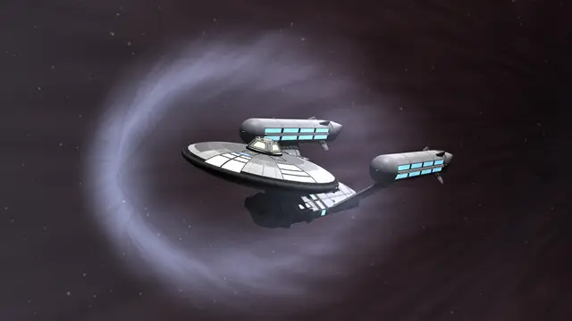

**FTL: Flyingsaucer Transaction Loader**

Testing Plans

**Background**

Flyingsaucer Transaction Loader (FTL) is a software to support a fast-food restaurant chain, the Flying Saucer. The three Entrees are Flying Saucer, Crashed Saucer, Livestock Mutation, and Outer Omelette. The Sides are Crop Circle, Glowing Haystack, Taken Bacon, Missing Links, Eviscerated Eggs, and You're Toast. Finally, the Drinks are Liquified Vegetation, Saucer Fuel, and Inoragnic Substance. You will evaluate whether the desktop application can successfully take orders from customers and perform transactions.

**Purpose**

The application basically consists of a main menu screen (1), a menu selection screen (2), and an order summary screen (3).

The main menu screen (1) includes the menu selection screen and order summary screen, and additionally allows you to cancel the order with the Cancel Order button, redisplay the menu selection screen with the Back to Menu button, or initiate payment by clicking the Complete Order button.

The menu selection screen (2) displays four Entrees, six Sides, and three Drinks menu items and allows the customer to select them by clicking buttons.

The Order Summary screen (3) displays the prices and customizations for the items that the customer selected on the menu selection screen (2), and shows the subtotal, tax, and total of the order. The order summary screen displays each menu item in order, and you can click on a menu item to customize it or remove it from the order by clicking the delete button on the right. Customized special instructions are also displayed expanded under an arrow, and you can click the arrow to collapse or expand the special instructions.

Starting from this main menu screen, you will evaluate whether you can properly select and customize each menu item, and ultimately whether you can use cash to make change and pay for it properly in subsequent orders, and whether all of the customized item attributes and amounts are correct.

**Entrees**

1. *Flying Saucer*
2. Launch the application
3. Select the “Flying Saucer” button from the “Entrees” menu

1. Click the Flying Saucer item of ID: 1 in the Order Summary Screen. The app should switch to a customization screen that looks like this:

There should be checkboxes for “Berries”, “Syrup”, and “Whipped Cream”, and a count box for "Stack Size" which default value is 6.

|  |  |
| --- | --- |
| Initial | Test Item |
|  | Berries |
|  | Syrup |
|  | Whipped Cream |
|  | Stack Size of 6 |

A Flying Saucer entry should appear in the order, with a cost of $8.05

|  |  |
| --- | --- |
| Initial | Test Item |
|  | Flying Saucer in the order |
|  | Price of $8.05 |

1. Uncheck the checkboxes and increase Stack Size to 12 clicking ‘+’ button, and a corresponding “Hold” detail should appear in the order, i.e., un-checking should cause the order to look like:

|  |  |
| --- | --- |
| Initial | Test Item |
|  | Berries checkbox appears and functions |
|  | Syrup checkbox appears and functions |
|  | Whipped Cream checkbox appears and functions |
|  | Stack Size countbox appears and functions |

1. Click the “Back to Menu” Button. This should return you to the main menu screen, with the order still containing the details about the Flying Saucer with delete button:

|  |  |
| --- | --- |
| Initial | Test Item |
|  | With “12 Pancakes” |
|  | With “Hold Syrup” |
|  | With “Hold Whipped Cream” |
|  | With “Hold Berries” |
|  | Flying Saucer in the order |
|  | Price of $13.00 |
|  | Delete button appears |

1. Finally, click the red ‘X’ button in the Order Summary Screen to remove the item and checks that the “Subtotal”, “Tax”, and “Total” return to 0.

|  |  |
| --- | --- |
| Initial | Test Item |
|  | Delete button functions |
|  | Flying Saucer Item has been removed |
|  | Prices change to 0 |

1. *Crashed Saucer*
2. Launch the application
3. Select the “Crashed Saucer” button from the “Entrees” menu
4. Click the Flying Saucer item of ID: 1 in the Order Summary Screen. The app should switch to a customization screen that looks like this:

There should be checkboxes for “Syrup”, and “Butter”, and a count box for "Stack Size" which default value is 2.

A Crashed Saucer entry should appear in the order, with a cost of $6.45

1. Uncheck the checkboxes and increase Stack Size to 6 clicking ‘+’ button, and a corresponding “Hold” detail should appear in the order, i.e., un-checking should cause the order to look like:
2. Click the “Back to Menu” Button. This should return you to the main menu screen, with the order still containing the details about the Crashed Saucer with delete button:
3. Finally, click the red ‘X’ button in the Order Summary Screen to remove the item and checks that the “Subtotal”, “Tax”, and “Total” return to 0.
4. Livestock Mutilation
5. Outer Omelette

**Sides**

1. Crop Circle
2. Glowing Haystack
3. Taken Bacon
4. Missing Links
5. Eviscerated Eggs
6. You’re Toast

**Drinks**

1. Liquified Vegetation
2. Saucer Fuel
3. Inorganic Substance

Testing Currency

1. Add one Flying Saucer to the order and click the Complete Order button

1. Click the Cash payment button

1. The you will see this cash payment screen

1. Add two $100 to the Customer currency. Then you can check that four $20, ten $10, three $1, three 25¢, two 10 ¢ is add to the Give As Change box for the $188.95 Change Owed. Then click the Finalize Sale button to finalize order.

1. After finalized order, do the same step 1-4. But this time add one $100 to the From Customer currency. If you click the Finalize Sale button. The error window would be appeared. Because there is not enough currency in the static Cash Drawer field.